WHITESTONE PRIMARY SCHOOL
CITY AND COUNTY OF SWANSEA
YSGOL GYNRADD Y GARREG WEN



GOVERNORS ANNUAL REPORT
2024-2025

Headteacher Mrs B. Peterson
E-mail: WhitestonePrimarySchool@whitestone.swansea.sch.uk
Web address: www.whitestone.swansea.sch.uk



ANNUAL REPORT OF THE GOVERNING BODY TO PARENTS 2024-2025

The Annual General Meeting of the Governing Body was held on Wednesday 23rd September 2024. The minutes of these meeting are available on request from the school office.

Mr Gareth Ford was re-elected as Chair and Ms Pauline Lewis as Vice-Chair. The Governing Body comprises of teachers and non-teaching staff, parents, members of the local community and members of the Local Authority (LA). Vacancies arise on a regular basis when terms of office expire and your interest would be welcomed if you have a desire to make a contribution to the success of the school.

Legislation states that an Annual Parents’ Meeting with Governors is no longer statutory, however, parents may petition a meeting with the Governing Body under certain circumstances. You may either request information regarding this process from the school office, or access it from the school website.

Chairman: Mr. Gareth Ford, Whitestone Primary School, Rushwind Close, West Cross, Swansea, SA3 5RF
Tel: 01792 404113

Contact Mrs C Scott, Clerk to the Governors
Whitestone Primary School, Rushwind Close, West Cross, Swansea, SA3 5RF
Tel: 01792 404113
Email: WhitestonePrimarySchool@whitestone.swansea.sch.uk

CHAIR’S REPORT
Welcome to this year’s Annual Report to Parents.
This report offers an overview of school life, including key statistics and achievements, as outlined in the Governors’ Annual Report. As Governors, we take this opportunity to summarise the role and responsibilities of the Governing Body in fulfilling its duties.
Throughout the past academic year, the staff have continued to make significant progress in developing the Curriculum for Wales and implementing changes related to the Additional Learning Needs (ALN) system. We, the Governors, would like to acknowledge and commend the dedication and hard work of the leadership team at Whitestone.
Finally, I would like to extend my sincere thanks to you, our parents, for your continued support and cooperation. It is with great pleasure that I present this report to you.
Gareth Ford
Chair of Governors
MEETING
No Governing Body meeting for parents was held in the previous academic year 2024-2025 and no petition to hold a parents meeting was received.

GOVERNING BODY STRUCTURE
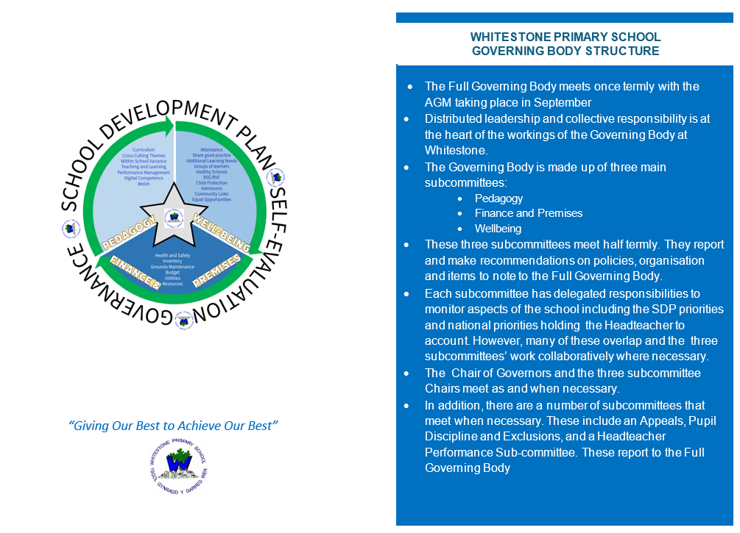

GOVERNING BODY MEMBERS

Name | Category |  | Term End Date
Mr G Ford | LA Representative | Chair of Governors | 27/7/2026
VACANCY | LA Representative
Mrs C Stilwell | LA Representative |  | 25/10/2027
Mrs P Erasmus | Community Council |  | 7/5/2028
Mrs C Morgan | Parent Governor |  | 6/11/2026
Mr J Parmar | Parent Governor |  | 6/12/2027
Mr J Chapman | Parent Governor |  | 7/1/2029
Mrs C Mitchell | Parent Governor |  | 26/10/2028
Mrs P Lewis | Community Governor | Vice Chair | 7/2/2026
Mrs G Morris | Community Governor |  | 7/5/2028
Mr A Thomson | Community Governor |  | 20/3/2028
Mrs J Dawson | Associate Staff Representative |  | 20/3/2028
Mrs C Johns | Teacher Governor |  | 1/9/2024
Mrs B Peterson | Headteacher | WhitestonePrimarySchool@whitestone.swansea.sch.uk
Mrs R Kissick Observer | Deputy Headteacher | Observer

Any vacancy which arises for Parent Governor will be advertised accordingly.
FINANCIAL REPORT 2024-2025
The budget is one of the most important areas of the Governors’ responsibilities. The Head Teacher manages the budget on a day-to-day basis on behalf of the Governing Body. The Head Teacher liaises closely with the Primary Support Officer (PSO) and the Finance Sub Committee who have to set budget limits for a range of resources. In accordance with the requirements of the Education Reform Act 1988, the statement of Actual Gross Expenditure for the year ended March 2023 is outlined below.

SCHOOL: Whitestone Primary
STATEMENT OF ACTUAL EXPENDITURE 2024/25 FINANCIAL YEAR
 | Delegated Expenditure | Non-Delegated Expenditure | Total Net Expenditure
 | £ | £ | £
Teachers Salaries | 597,740 | 0 | 597,740
Salaries | 415,654 | 25,150 | 440,803
Other Employee Costs | 940 | 39 | 979
Premises | 9,972 | 0 | 9,972
Transport | 0 | 247,853 | 247,853
Supplies & Services | 238,608 | 362 | 238,970
Recharges | 0 | 78,807 | 78,807
Gross Expenditure | 1,262,914 | 352,210 | 1,615,124
Grant Income | -178,777 | 0 | -178,777
Other Income | -138,001 | 0 | -138,001
Gross Income | -316,777 | 0 | -316,777
Net Expenditure | 946,137 | 352,210 | 1,298,347
RESERVES: |  | £
FINAL FORMULA ALLOCATION: |  | 942,101
TOTAL NET EXPENDITURE: |  | 946,137
TRANSFER TO / (FROM) RESERVES: |  | -4,036
OPENING BALANCE ON RESERVES 01/04/24 |  | 57,573
CLOSING BALANCE ON RESERVES: 31/03/25 |  | 53,537
No governors claimed travelling or subsistence expenses during 2024-2025

SCHOOL TRIPS AND VISITS
As a school we like to provide a range of different experiences, visitors and educational visits for our pupils. We understand the pressures families face with financial issues and we always ensure we seek best value for money and wherever possible we provide free or subsidised events.

Please see all of the activities, visits and trips that were undertaken to enrich the children’s learning, experiences and the curriculum.
26.09.2024 | Whole School to the Taliesin ‘Fish Boy’
27.09.2024 | African Drumming Workshop – whole school
13.11.2024 | Theatre Na N’og Trip - Badgers
18.11.2024 | Bronze Ambassadors to LC2
20.11.2024 | Rights Respecting School Ambassadors – Waterfront Museum
3.12.2024 | Fox Class – Performed Christmas songs in Swansea City Centre. Also attended Newton Court
19.12.2024 | Christmas Wrapped Up – Castleton Church – Squirrel Class
10.1.2025 | South Wales Fire Service – Fire Safety workshops
26.3.2025 | Rabbit Class visit to the Glynn Vivian Art Gallery
3.3.2025 | Rabbit Class visit to Oystermouth Library and Mumbles
5.3.2025 | Y6 Residential to Llangrannog
31.3.2025 | Rabbit class trip to library and Oystermouth Castle
14.3.2025 | Welsh Transition work with Bishop Gore – Criw Cymraeg (3)
1.4.2025 | Squirrel Class visit to UWTSD to participate in the Immersive Room
7.4.2025 | Fox Class visit to Oystermouth Library to learn about Victorians and on to the beach for Expressive Arts work
8.4.2025 | Hedgehog Class to Football Tournament
9.4.2025 | Criw Cymraeg reps to Portmead Primary to share Welsh reading
10.4.2025 | Squirrel Class to Castleton Church for Easter celebrations
2.5.2025 | 3 x Year 5 to Bishop Gore to plan Olympics with the Cluster
30.4.2025 | Whitestone Earth Day
1.5.2025 | Cash for Kids clothes collection
2.5.2025 | 4 x Y5 pupils to Bishop Gore to plan the Olympics Sports Event
12.5.2025 | Cycling Proficiency training x 4 days
13.5.2025 | Fox Class – Tennis Festival
20.5.2025 | Mad Science Assembly
21.5.2025 | Fox and Badger Class - Cricket Development Day
11.6.2025 | Class Photos
17.6.2025 | Fox Class visit to Mount Pleasant Baptist Church and Glynn Vivian Art Gallery
19.6.2025 | Sports Days
20.6.2025 | Enterprise Project Market Day – Years 2 and 6
20.6.2025 | Bishop Gore Olympic Sports at Swansea University Sports Centre
23.6.2025 | Badger Class visit to Swansea University – STEM project
24.6.2025 | Fox Class visit to Oystermouth Castle – Battle of Gwyr

PUPIL VOICE AND ACTIVE CITIZENSHIP
The school works with charities that promote active citizenship such as Childline and Children in Need. Pupils and parents are encouraged to become aware of local, national and global issues faced by children. We promote a sense of community and respect. Whitestone Primary School pupils are encouraged to be active and informed citizens who look after their school local community and beyond to develop a positive future for all. We have 6 pupil voice groups at Whitestone – School Council, Eco-Committee and Criw Cymraeg as well as our School Council which is made up of the chair and vice chair of each group. The learners take their responsibility very seriously and show commitment for the good of our school. These activities develop children’s sense of well-being as they focus on needs of others around them and their relationship with those around them.

TEACHING AND LEARNING
Whitestone Primary School is an inclusive and nurturing school. Our ethos is positive and we have been repeatedly complimented by a range of visiting professionals, families and members of the wider community on our warm and welcoming atmosphere and the open and caring culture that is evident throughout the school. We believe that the quality of relationships lies at the heart of our success. Relationships between staff and pupils, staff and parents, staff and governors and of course between staff and their colleagues are based on mutual trust and respect and underpin our development. We work hard to ensure staff are happy, enthusiastic, cooperative, dedicated, hardworking and organised with a shared philosophy. We celebrate the fact that our children are also happy and hardworking and that they all have the opportunity to experience success and to feel that they have a real contribution to make to the life and working of our school. Principles of the Curriculum for Wales are embedded within the school’s planning and great focus is placed upon giving the pupils experiences to develop in line with the four purposes of the new curriculum.

We are in a time of significant change in primary education. Planning and assessment of a skills continuum is at the heart of this change, in addition to raising standards in reading, writing, numeracy and digital competency. Principles of the Curriculum for Wales are embedded within the school’s planning and great focus is placed upon giving the pupils experiences to develop in line with the four purposes of the new curriculum. Annual National Tests are undertaken in Reading and Numeracy each May for all pupils from Y2 to Y6. Parents are informed of their child’s scores in these tests at the end of the Summer Term. The school uses this, and other data, to track pupils’ progress, inform teaching and learning and also to identify and support individual pupil needs. Our Curriculum for learning policy is updated and reviewed regularly, and our purpose based curriculum planning is continually reviewed. Governors and members of staff have worked closely with the Head teacher regarding school self-evaluation, assessment and raising standards.

MORAL AND SOCIAL DEVELOPMENT
We have a Health and Well-being, RVE and RSE scheme which helps guide and support the moral and social development of our pupils. Our school ethos and school policies such as Behaviour and Discipline, our Areas of Learning and Experience, Pupil Progression @ Whitestone skills ladders, along with our strategic equality plan support this area.

WELSH
Whitestone Primary School is an English medium school and communications with parents are provided through the medium of English. We are very aware of our role as a school in Wales, in promoting and developing the use of Welsh as a living language. In addition to sessions where we teach Welsh as a second language, the school promotes the language as the working language of the school. Simple instructions (sit on the carpet / line up for break etc.) are given through the medium of Welsh, where pupils hear the language and respond to it through action. Staff and pupils greet each other throughout the day using the medium of Welsh and pupils are encouraged and supported to use the sentence patterns they know outside of the classroom in the playground. In addition to this we have a daily session of about ten minutes where the children use Welsh language. This is known as the ‘Slot drilio’ session. The session is utilised to ensure that patterns of speech are re-enforced and used on a regular basis.


Welsh is taught as a second language throughout the school. All members of staff have undertaken professional learning to support them in this area. Training is supported by the LA Specialist Teacher, Mrs Richards who assists both pupils and staff. Progress in Welsh is achieved through oracy, with some reading and writing activities as appropriate. Staff plan lessons so that the children meet all types of activities on a regular basis. Children work as individuals or members of a group. This includes opportunities to take part in drama and role-play activities. We have a number of stories that the children can read and listen to and Welsh software for the computers.
PHYSICAL DEVELOPMENT
Physical Development and sport continue to be a very important part in the life of our school. Pupils are given the opportunities to participate in physical education in the curriculum along with being offered various after school clubs. Physical Education is a timetabled part of our curriculum in all classes, which ensures children receive broad and balanced opportunities in their learning. In addition, the philosophy of the Foundation Phase ensures children have access to adventurous and physical activities throughout the day.

Whitestone is a Healthy School and has been awarded the Phase 5 of the Healthy Schools Award. Children are encouraged to eat and drink healthily. Extra-curricular Sport is offered for learners in the Junior Classes.

ADDITIONAL LEARNING NEEDS
Transition from the special educational needs (SEN) system to the additional learning needs (ALN) system is now complete.

When a parent, carer or member staff has a concern related to the academic progress, emotional development or medical condition of a pupil, they bring their concerns to the attention of the Additional Learning Needs co-ordinator (ALNCO). The ALNCO, appropriate staff members and family will then meet and decide on a course of action.

When considering if a pupil has an additional learning need (ALN), we follow a decision making process:

Does the child or young person have a learning difficulty or disability?

The key questions that need to be asked are:
i) Does the child or young person have a greater difficulty in learning than the majority of others of the same age?
ii) Does the child or young person have a disability (within the meaning of the Equality Act 2010) which prevents or hinders the child or young person from making use of facilities for education or training of a kind generally provided for others of the same age in mainstream maintained schools.

If the answer to either (or both) questions is ‘yes’, it is necessary to proceed to apply the second test. If the answer is ‘no’ to both questions, the child or young person does not have ALN.

(b) Does the learning difficulty or disability call for additional learning provision (ALP)?

‘Additional learning provision’ for a person aged three or over means educational or training provision that is additional to, or different from, that made generally for others of the same age in Mainstream maintained schools in Wales. This will be distinct from the teaching strategies and differentiated teaching that is generally available for all learners. We will continue to provide carefully planned interventions to support a range of needs which will be available as part of our universal provision for the benefit of all learners.

If the child or young person has a learning difficulty or disability which calls for ALP, the child or young person has ALN for the purposes of the Act.

If an ALN is identified, an Individual Development Plan will be put in place.

At Whitestone Primary School, we are committed to offering an inclusive curriculum in order to ensure that all our pupils achieve their very best.
Pupil wellbeing is paramount.
The school promotes a person-centred approach to planning. Personalising education is about recognising that every pupil with additional learning needs is an individual. By focusing on what matters to each individual child we can respond to their particular needs. Each pupil with additional learning needs can be taught and supported in the best possible way to ensure that they reach their potential.
We work in collaboration with many outside agencies including the Educational Psychologist, the Advisory Teachers, Speech and Language Therapists, Health Professionals and the Behaviour Support Service. Our well trained and experienced support staff deliver a number of intervention programmes aimed to target a range of difficulties and abilities. Such programmes include Speech and Language Therapy, Wellcom, ELSA and Sensory Circuits.
BEFORE SCHOOL ARRANGEMENTS
The school offers a free breakfast service to pupils of Nursery age and above. This service, which starts at 7.50 a.m. offers a range of nutritious foods. Our Breakfast supervisory assistants and canteen staff must be commended for the way they welcome the pupils every day. Their work is very much appreciated and doesn’t go unnoticed.

TOILET FACILITIES
The toilet facilities are accessible to all users within the school and specialist provision is in place for children with disabilities. Each toilet area also has washbasins, liquid soap and paper towels or hand driers. The toilets are thoroughly cleaned daily by our cleaning staff, who are employed by the City and County of Swansea and if there is a need, cleaned at other times as required.

SCHOOL POLICY
We regularly review and update our school policies. Reviews are undertaken on a rolling programme, led by relevant subject leaders. Review of policies ensures the inclusion of new developments, resources and methodologies particularly with the Government drive on safeguarding and raising standards in literacy and numeracy. Copies of school policies can be obtained from the school office and many are available on our school website.
The following policies have been reviewed this year:

- Health and Safety Policy
- Safeguarding/Child Protection Policy
- Attendance Policy
- Marking and Feedback Policy
- Teaching for Learning Policy
- Lockdown Policy
- Admissions Policy
- Pay Policy
- Safe Use of Internet Policy

Personnel
Areas of Learning Teams | AOLe Lead | Team
Language, Literacy and Communication | Mrs C Lewis | MG, CJ, KF, VS, VC
Mathematics and Numeracy | Mrs R Kissick | CL, JA, HC
Science and Technology | Miss B Thomas/ Miss J Tanner | RK, JR, AH, GA
Humanities | Mrs S Jones | BP, JT, SM
Health and Well Being | Mrs K Croall | CL, SJ, RK, HE, JM
Expressive Arts | Miss M Griffiths | KC, BP, JD, FP, MB
First Aid | Mrs J. Dawson, Mrs M. Burns, Mrs C.Scott
Other areas of responsibility | Staff Name
Health and Safety | Mrs B. Peterson
Healthy Schools, School Council, Well-being | Mrs R. Kissick
Additional Learning Needs | Mrs C. Johns
Eco-committee | Mrs S. Jones
Associate Staff Role | Staff Name
School Office Manager | Mrs C Green/  Mrs C Scott
School Caretaker | Mr S Totterdell
Teaching Assistants | Miss G Allan  Mrs J Rushton  Mrs V Stote  Mrs F Price  Mrs M Burns  Mrs J Allen  Mrs K Fletcher  Mrs H Evans  Miss E Vaughan  Mrs V Cooze  Mrs J Dawson  Mrs J Clark  Miss C Clark  Mrs S Morgan

HEADTEACHER’S REPORT
The year has once again been one of many successes, highs and challenges. I feel privileged to lead a school which is so well supported by all stakeholders; parents, staff, governors and the wider community, and would like to thank you for all that you do to help ensure that Whitestone continues to be a successful school.

I would like to thank you personally for the support you provide to the school, the children and the staff – you help make Whitestone Primary a special place to work and a privilege to lead.

The PTA provided great support to the school throughout the year organising important events such as the Christmas and Summer Fayres, and the termly discos. I would like to thank the members of the PTA for their efforts throughout the year and for the important support they provide, raising much needed funds for resources and school trips.

The work of the School Council continues to be an important part of our school self-evaluation processes and I have been impressed with their involvement in the continued development of the curriculum.

Mrs B Peterson
Headteacher

SCHOOL DEVELOPMENT PLAN (SDP)
Parents are made aware of the focus via parent meetings and our school website. The SDP summary can be found on the school website.
Our SDP runs from September to July. Our targets are devised using a number of sources including work scrutiny, lesson observations, analysis of data, learning walks and listening to learners.

Objectives set for 2024-2025 were:

Priority 1 - To further develop and cultivate a school-wide culture of self and peer assessment that strengthens learners’ metacognitive abilities and fosters the continued development of cross-curricular skills
Priority 2 – To ensure provision of appropriate support and challenge for all groups of learners
Priority 3 – To develop distributed leadership to ensure increased accountability for improved learner outcomes

Governors receive half termly updates on progress being made.

COMMUNITY
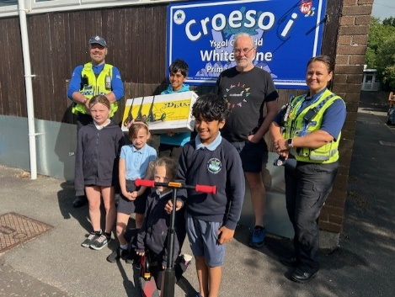
The school works in partnership with a number of community stakeholders. Parents continue to be overwhelmingly supportive to the school – the PTA have held a Christmas Fayre, Halloween, Valentine and Leaver’s Discos. In addition, they have organised a ‘Wonderful Women’ stall for the children in time for Mother’s Day, Marvellous Males stall in preparation for Father’s Day and a PTA Summer Fayre.

The Bring and Buy Uniform shop is continuing to prove to be popular and supports the work of the Eco-Committee who organised a clothes collection. Extra-curricular clubs have been offered including Film, Forest, Netball, Football, Make it, Board Games and Dance.

The School Council organised a Walking Bus which was very well attended, and followed the Big Walk to School event organised by SUSTRANS Wales. Our school was successful in achieving the highest amount of children walking or riding to school in Swansea during that week and were rewarded with a scooter.

A range of transition events were attended by our Year 6 children with their respective future Secondary schools; Bishop Gore and Bishopston Comprehensive schools.

The school also continued to support its partnerships with both further and higher education institutions and accommodated student placements.

SCHOOL TERMS AND HOLIDAY DATES
Term | Term begins | Mid-term holiday begins | Mid-term holiday ends | Terms ends
Autumn 2025 | Monday 1 September 2025 | Monday 27 October 2025 | Friday 31 October 2025 | Friday 19 December 2025
Spring 2026 | Monday 5 January 2026 | Monday 16 February 2026 | Friday 20 February 2026 | Friday 27 March 2026
Summer 2026 | Monday 13 April 2026 | Monday 25 May 2026 | Friday 29 May 2026 | Monday 20 July 2026

SCHOOL ATTENDANCE
The school exceeded its target of achieving at least 92% and for the whole of the academic year 2024-2025 attained 92.5% attendance.
Present | 92.5%
Authorised Absence | 7.1%
Unauthorised Absence | 0.5%

SCHOOL PROSPECTUS
The school prospectus is reviewed and updated annually with staff changes. It is available on request from the school office as well as being accessible via our website.

And finally…
Partnerships between parents, teachers, associate staff and governors go a long way to ensuring that children make the most of the opportunities offered at our school. We aim to provide a secure, welcoming and stimulating educational environment, through which children can enjoy what is provided. If you have any suggestions or ideas then please come and tell us about them; we would be delighted to hear from you.

Article 31:

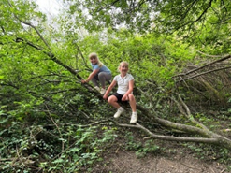
All children have the right to relax and play, and to join in a wide range of activities.

